# Insight Group Technologies Coding Challenge

Create a desktop application in C# that has X number of demand (customers) of points and Y number of supplier points. X will be supplied by closest Y.

This can be done using x, y coordinate pairs to derive distance. Straight line is acceptable. (Pythagorean theorem)

X and Y numbers should be user definable but in the prototype use something small like 100 Demand Points and 5 Supply Points.

Display the results in a Window with lines between the chosen supply point and customer node. The output should look similar but not limited to this:

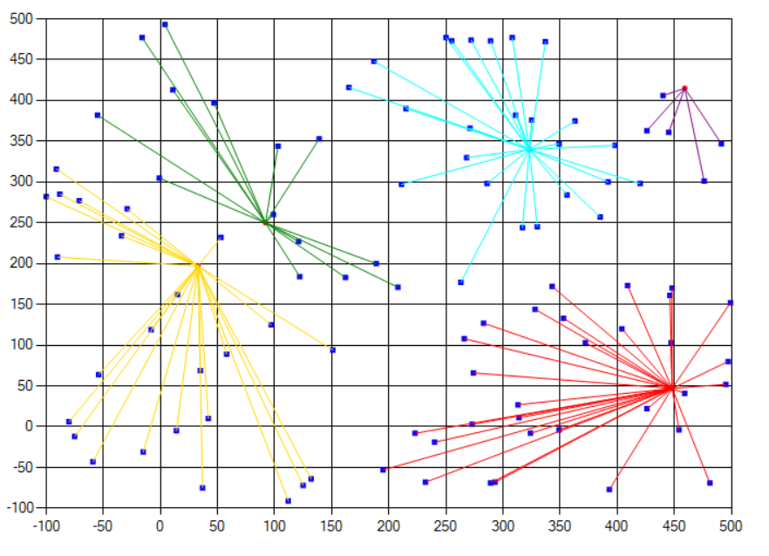

Use your creativity to provide user interaction and ease of use to create the supply and demand points.